**Add Binary:**

Taking two binary numbers represented as strings and adding them together as if they were base-2 integers. The task is to return the sum as a binary string

1. **Problem solving:**

**Initialization:**

Initialize variables to hold the result string, carry digit, and indices for traversing the input strings.

**Iterative Addition:**

Start a loop that iterates from the least significant digit (rightmost) of both input strings to the most significant digit (leftmost) or until there are no more digits left or carry remains.

**Extract Digits:**

Within each iteration, extract the current digits from both input strings. If there are no more digits left in a string, consider it as 0.

**Perform Binary Addition:**

Add the current digits along with the carry from the previous iteration. This sum is either 0, 1, or 2. Append the appropriate digit (sum % 2) to the result string and update the carry for the next iteration (sum / 2).

**Update Indices:**

Move the indices to the next digit towards the left for both input strings.

**Return Result:**

Once the loop completes, return the final result string.

1. **Flow chart**

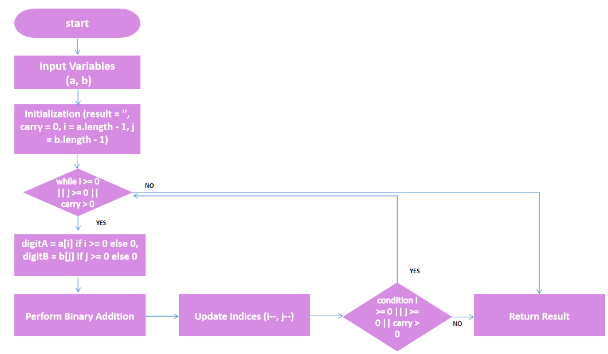

**End**

1. **Output**

